**In-Class Exercise # 6 – “Start Assembly Programming”**

Group: 61

Name & student ID: 陳宥涵 102401053 趙慈暄 104503002

Program execution flow

1. Before executing the program, first take a look at the initial registers we’re going to use in the future.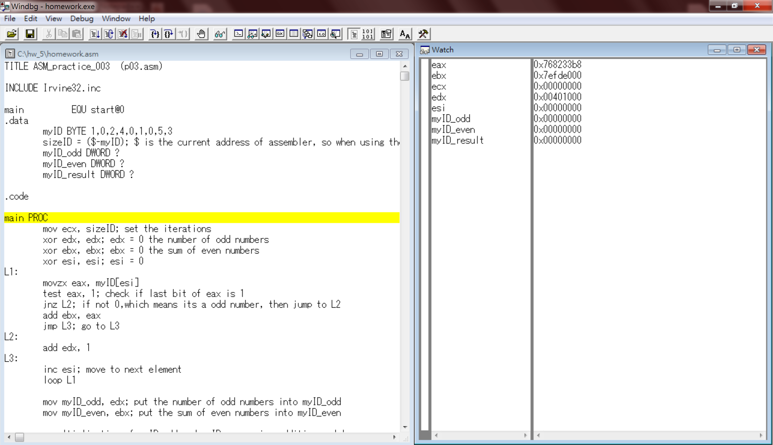
2. Set ecx to the size of the array, and clean edx, ebx, esi registers for further usage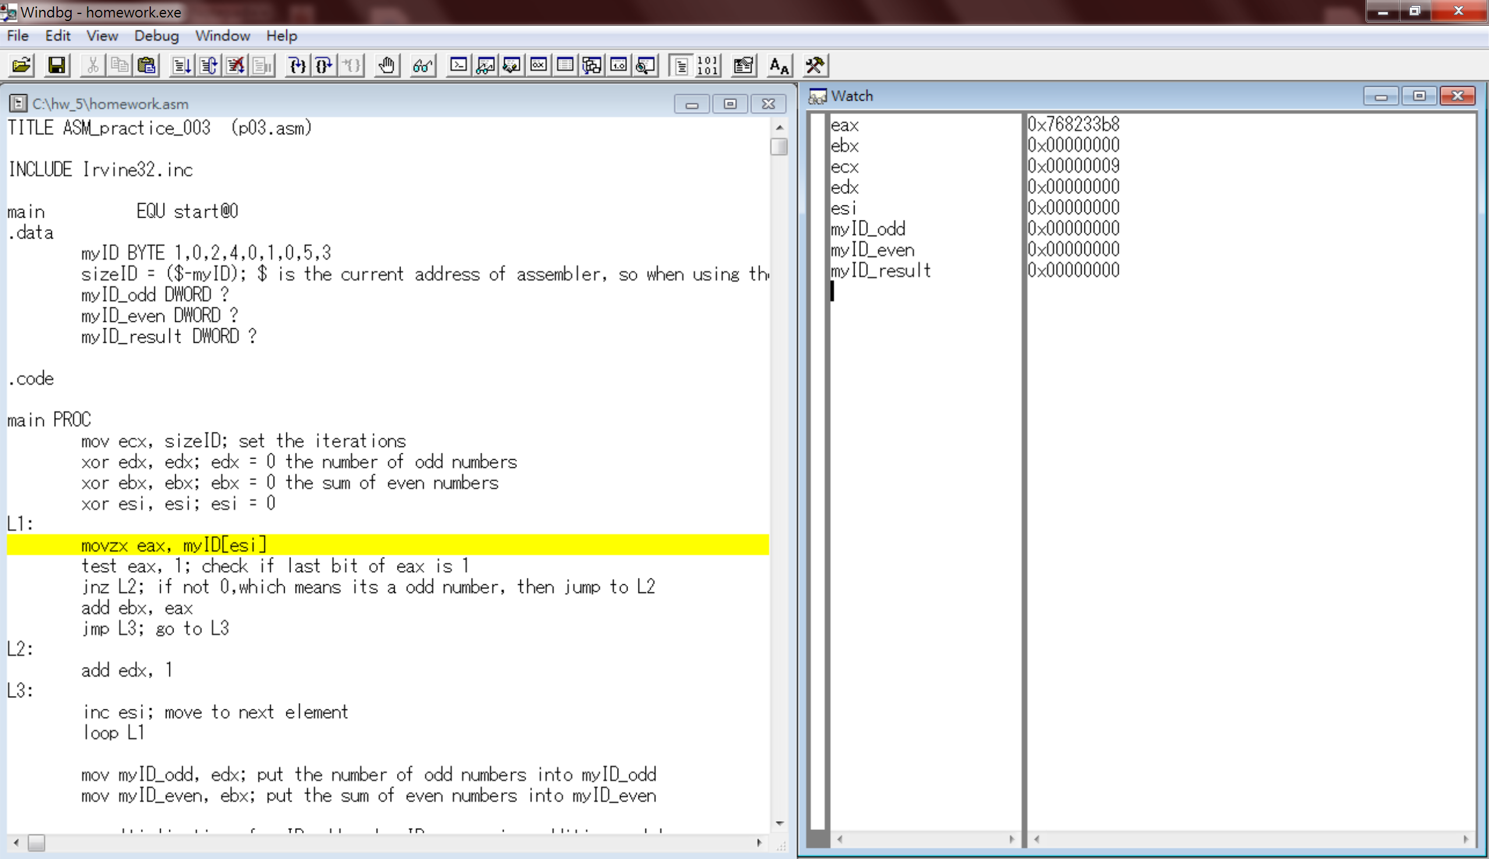
3. Since we have to iterate through the list of id numbers, we have to use a loop along with esi as the index. We first put the first element in the array which is now 1 to eax, so after proceeding this line of code we can see the value of eax changed to 1.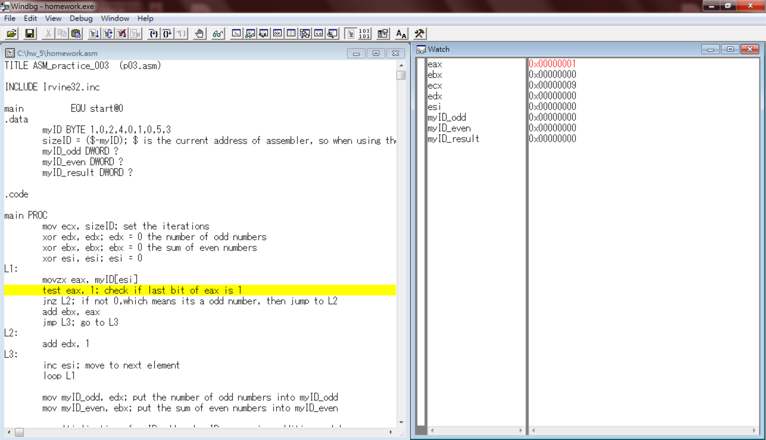
4. We we’re going to do is to check whether the current digit in eax register is even or odd, thus we test if the last bit of eax is 1 or not. Since in binary form, if the last digit is 1, it must be an odd number and vice versa. Since the current number is 1, which is an odd number, it will jump to L2 because the next line of code defines that if the value isn’t zero then jump to L2. Therefore, edx which is used as a counter for counting the number of odd numbers will be added by 1. Last, esi will be incremented by 1, which will point to the next element in the list in the next round. After this round, we expect edx to be added 1 and ebx stays as it was. 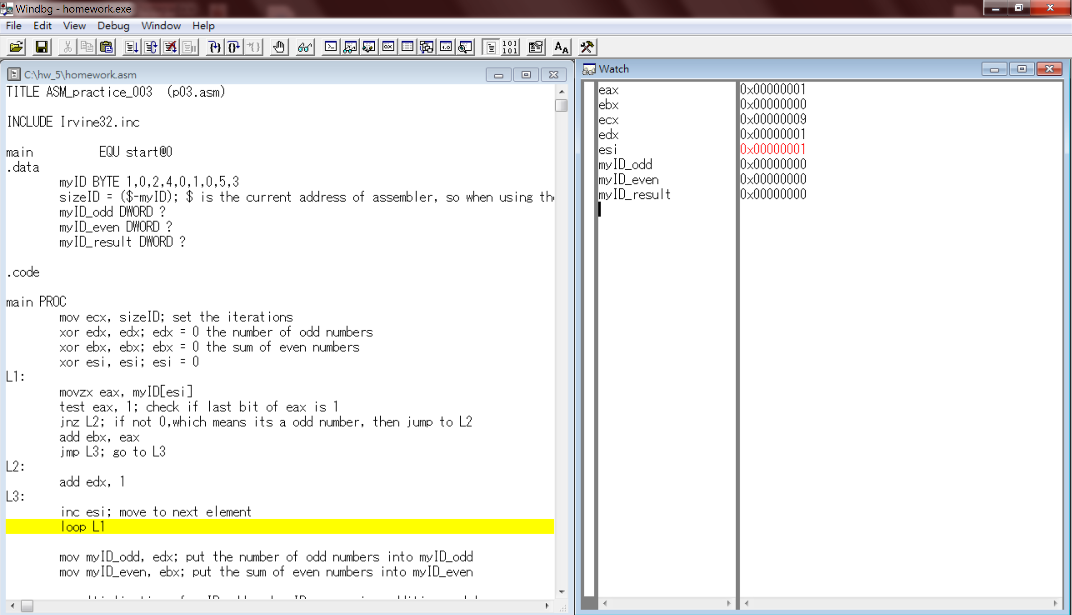
5. In this second loop, the element is now 0, which is an even number. Therefore, we expect it to go through “jnz L2” and add ebx by eax since ebx is the register that stores the sum of the even numbers in the list. We expect ebx to stay the same because eax is equal to 0, which makes no change after the addition. So then we will jump to L3 and increment esi and then end this round.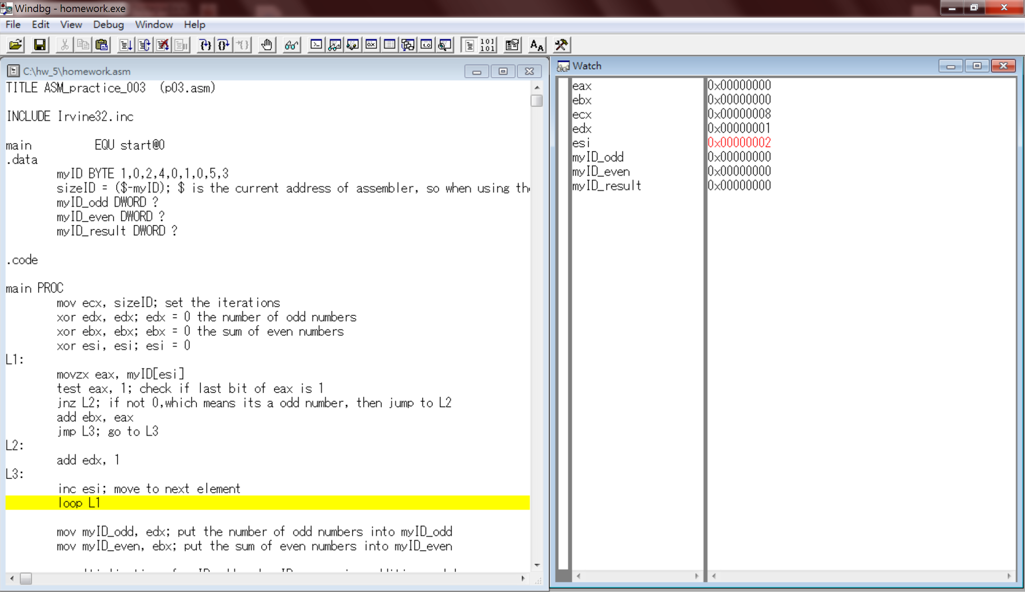
6. The third round, the current number eax will hold is 2, which is again an even number, so that we expect it to add 2 to ebx like the previous step. Then, jump to L3 increment esi and then end this round. After this round, we expect ebx to become 2.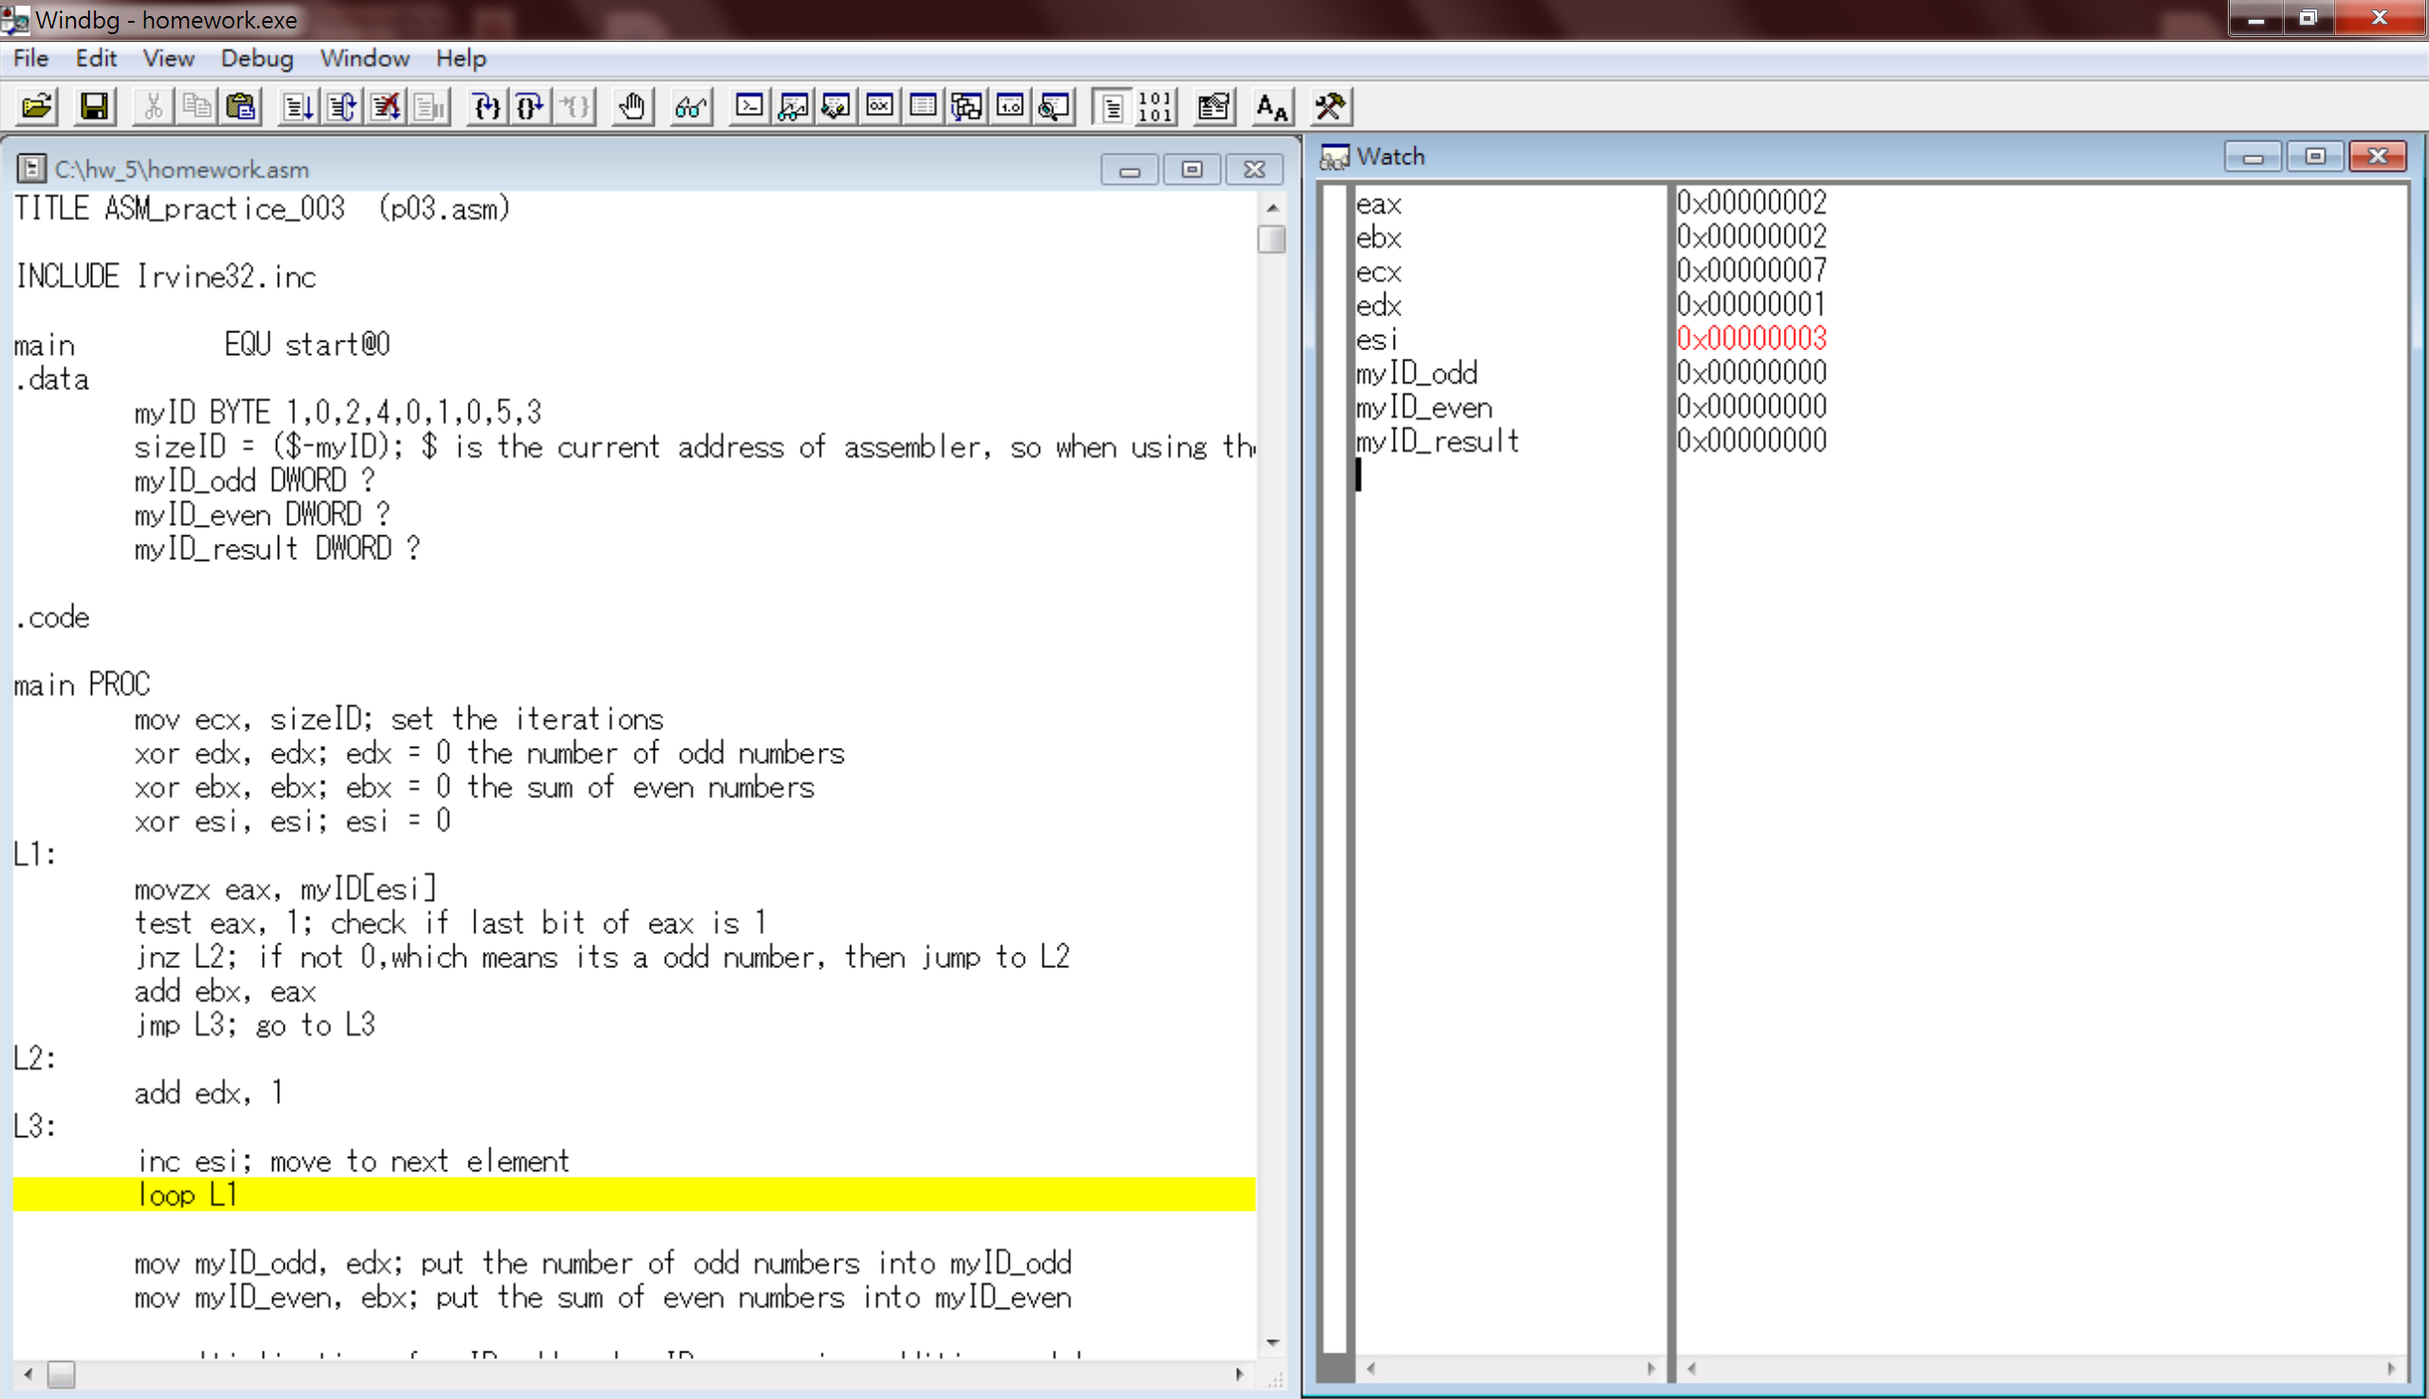
7. The forth digit of the list is 4 again, so we will again add 4 to ebx which will change the value of ebx register to 6. Then, we increment esi and move on to the next round.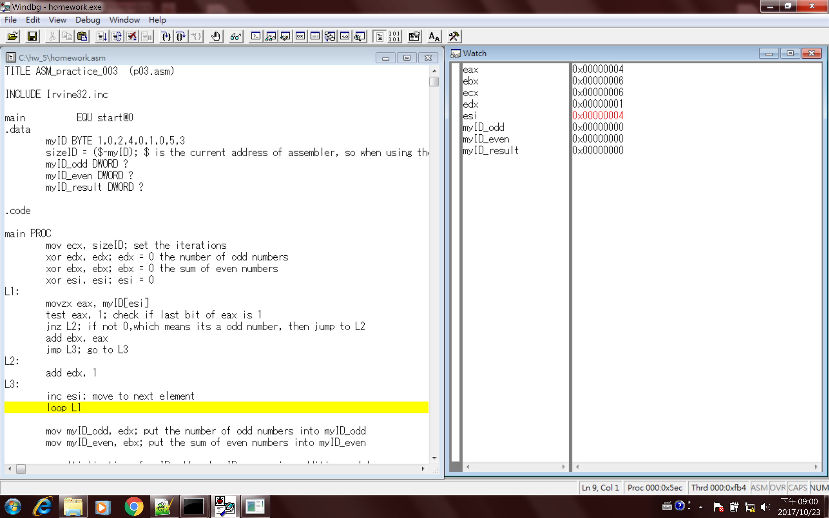
8. The fifth number is 0 again, an even number which will make no change to register ebx after the addition. Thus, the value of edx stays as 6, then jumps to L3 and increment esi.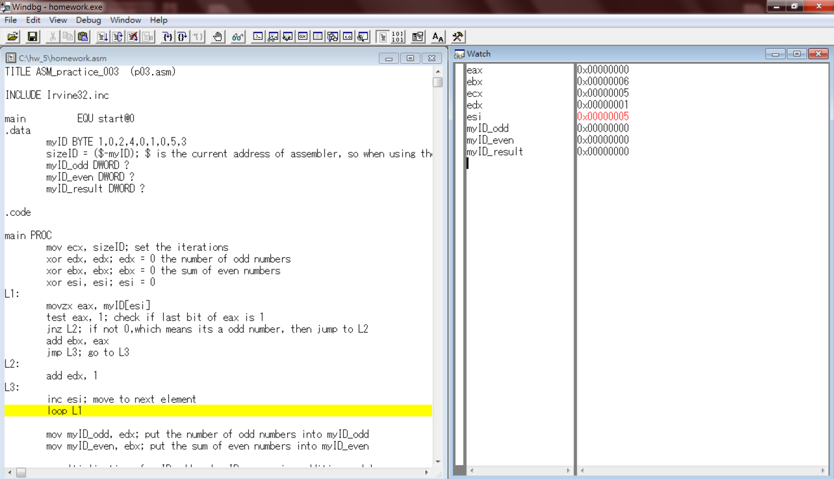
9. The sixth number is 1, an odd number. Hence, the last bit of eax will be 1, so that it will jump to L2 and add 1 to edx, so that edx now becomes 2, since so far we got 2 odd numbers already. Then, we increment esi and end this round.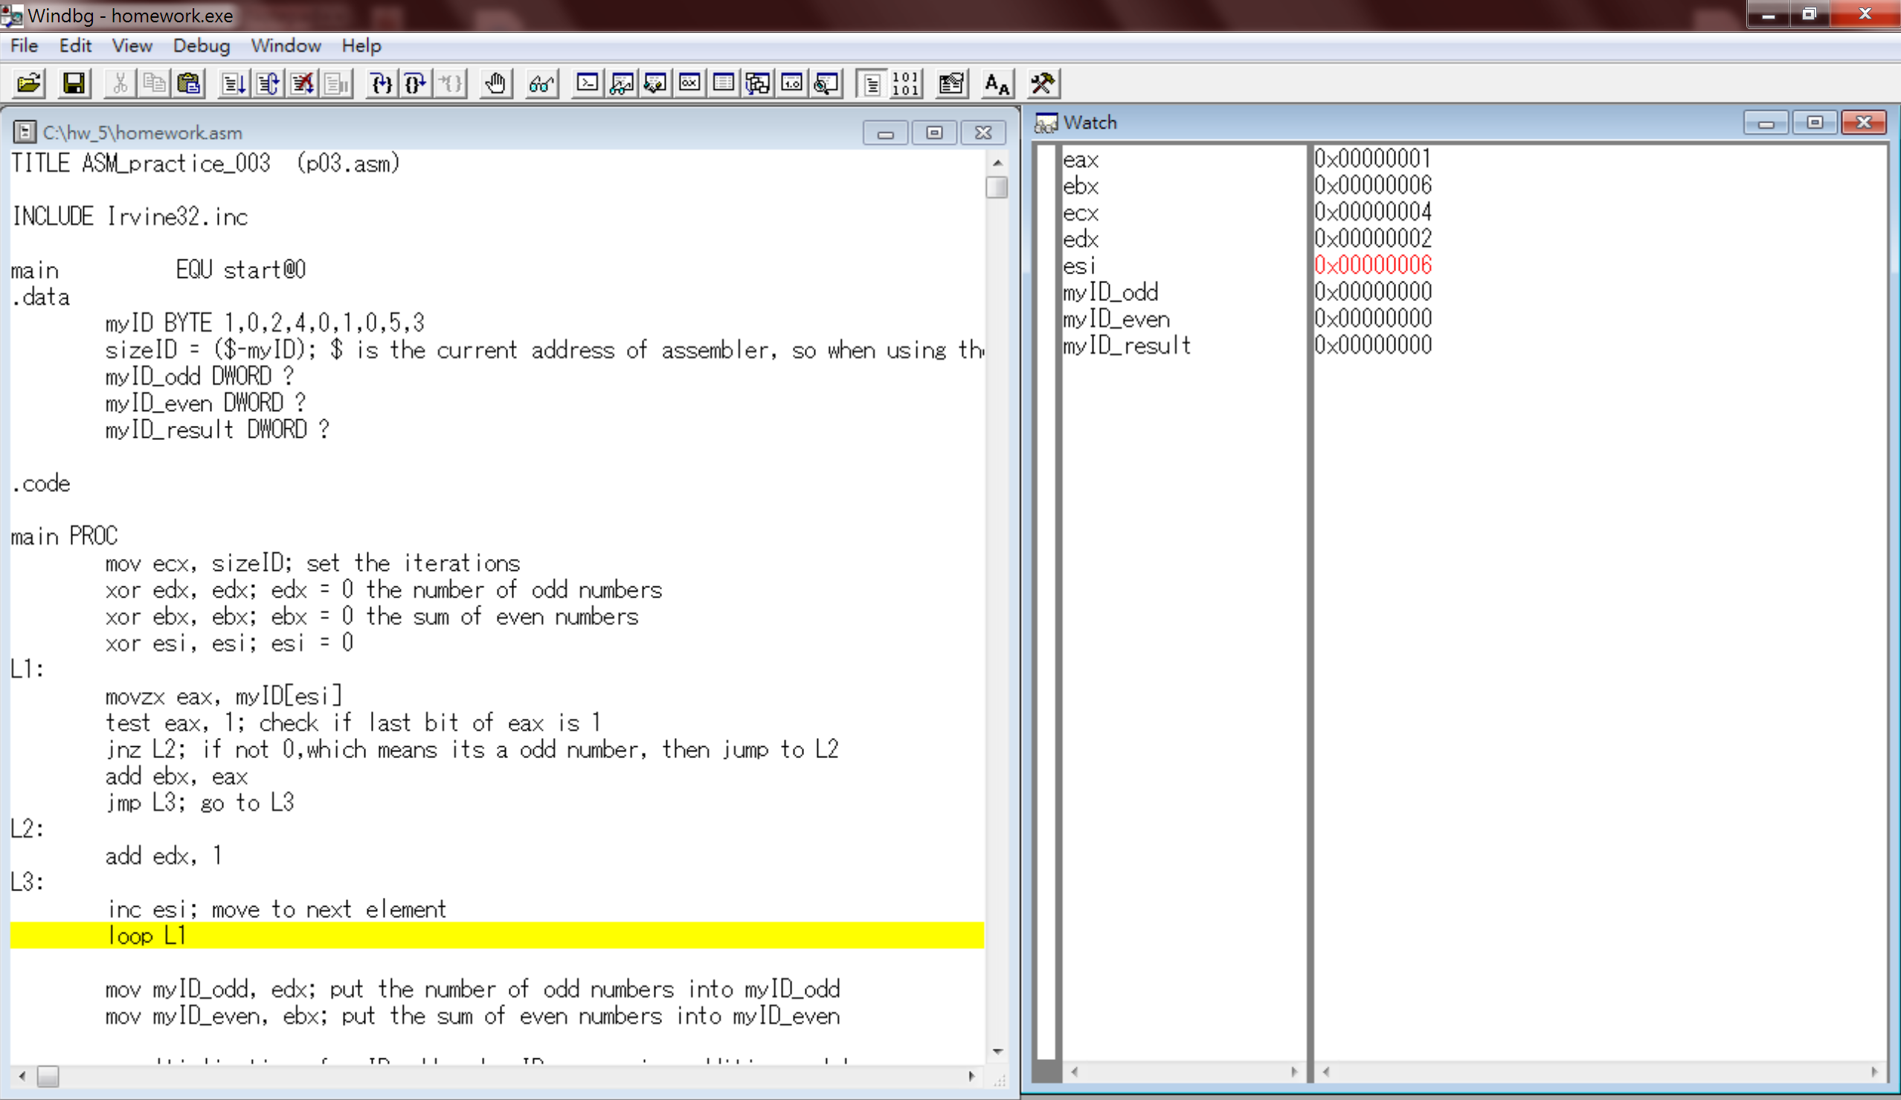
10. The seventh element of the list is 0, an even number. After testing eax, we will skip the “jnz L2” and then add eax to ebx, but since eax is zero, we can’t find any change in ebx. Then, we increment esi and then end this round.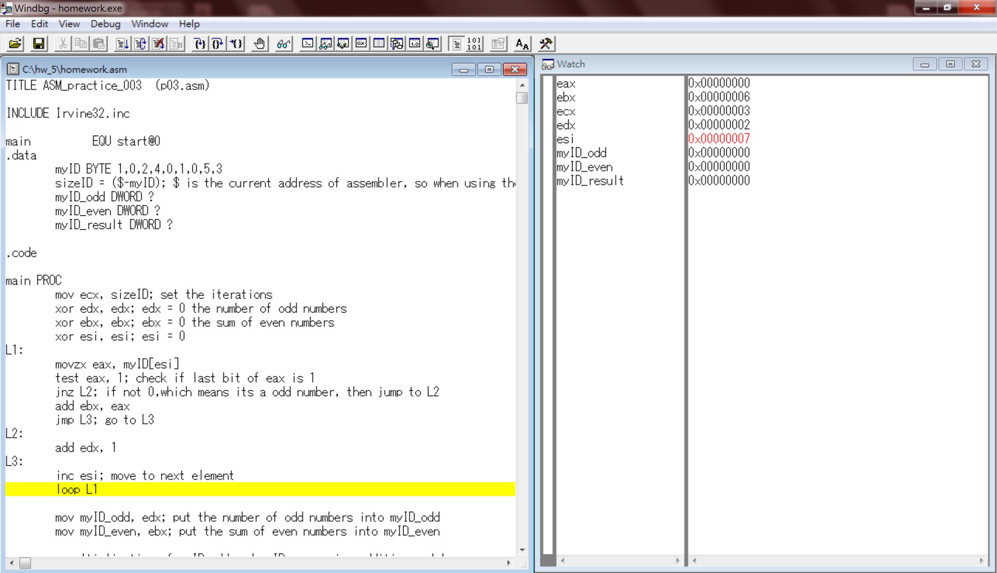
11. The eighth element is 5, and odd number. After testing eax, we will fulfill the condition and jump to L2, so that edx will be incremented. We expect edx to become 3. After then, again we increment esi.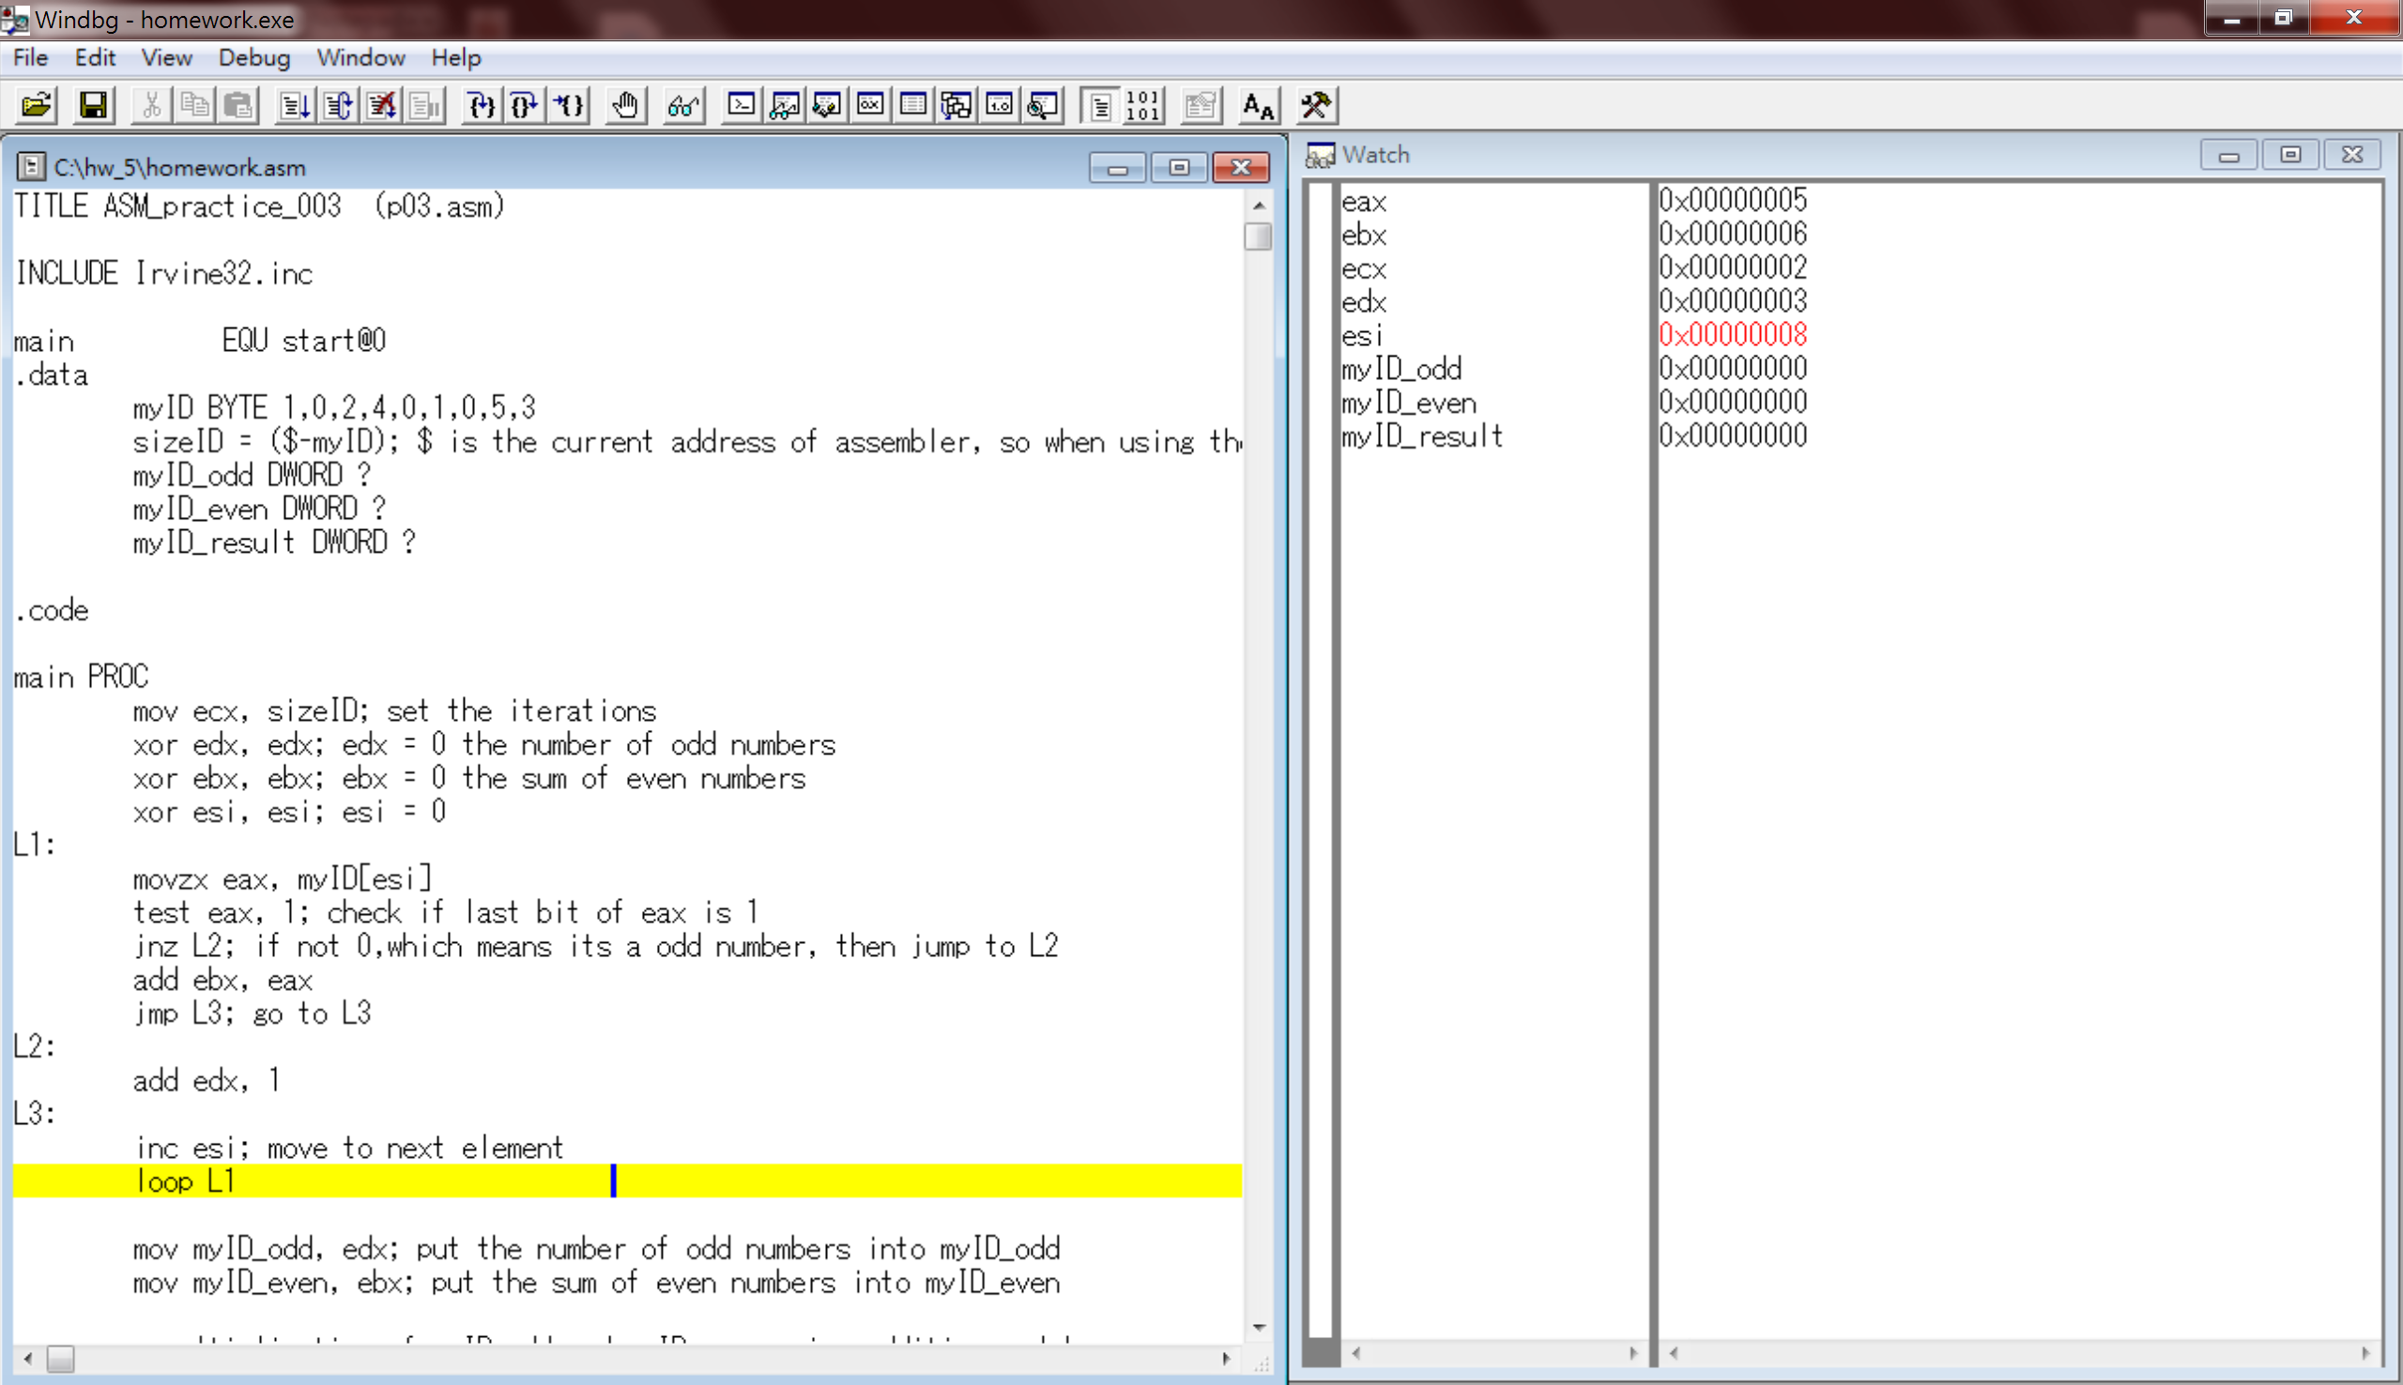
12. Last element of the list is 3, again an odd number. Since it’s odd, it will jump to L2 and increment edx by 1. Now, we expect edx to become 4, since it’s the forth odd number so far. Then increment esi.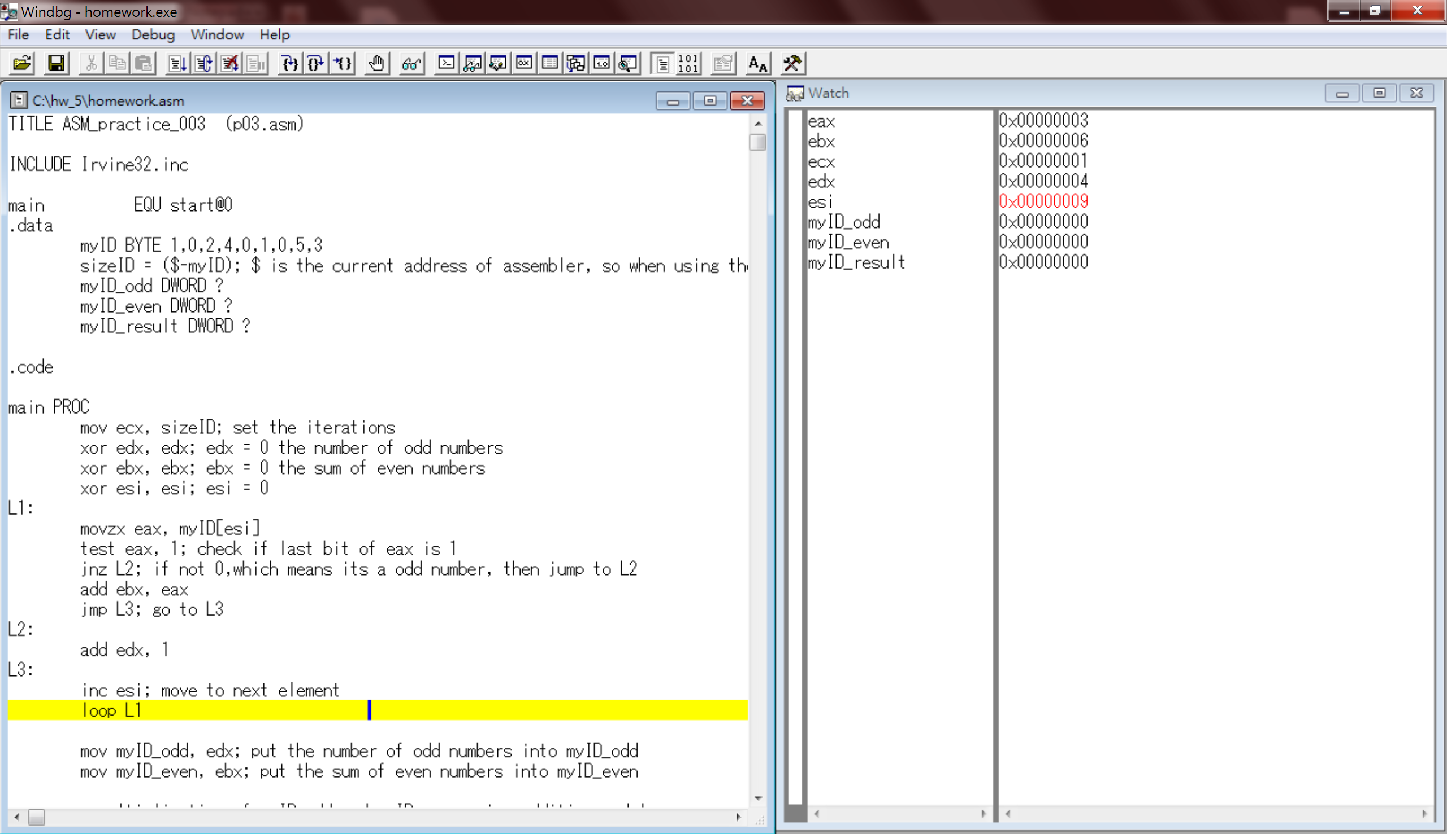
13. We finally finish the iteration over the element and we got 4 in edx register, which is the number of odd numbers in my student ID (102401053). In addition, we have 6 for ebx, which is the register to store the sum of even digits. (102401053 -> 0+2+4+0+0=6), which is in accord with the value we got in ebx. Therefore, we’re going to save edx to variable myID_odd and ebx to myID_even. We can see the value of myID_odd and myID_even now becomes 4 and 6 respectively.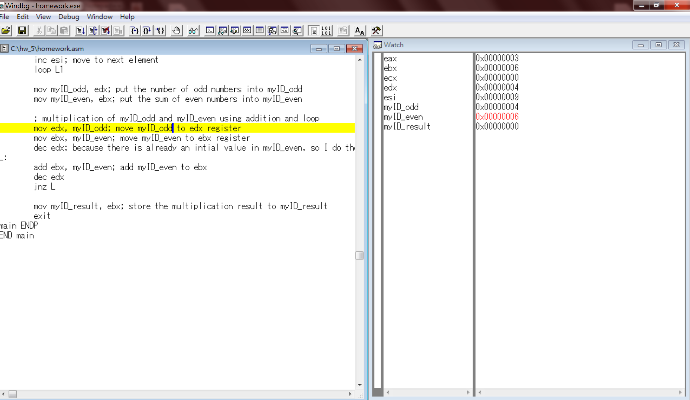
14. The next step, we’re going to multiply myID_even by myID_odd. So that we first store these two variables into registers. Since I didn’t clear the value in register ebx and edx, the value stays the same.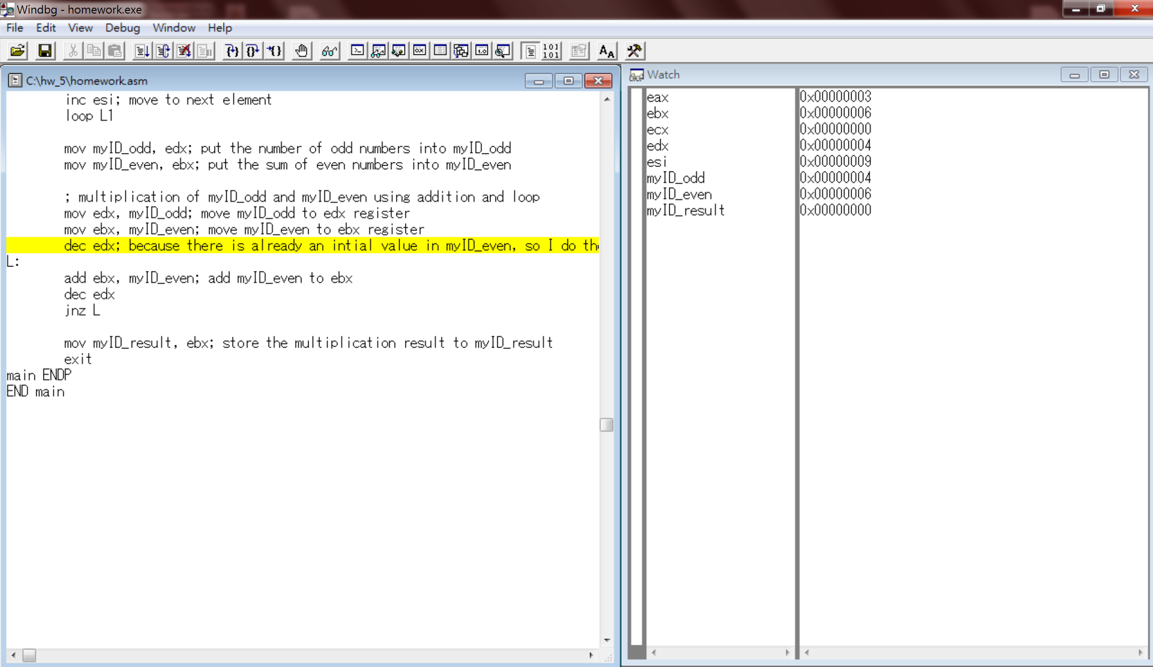
15. Next since we’re going to do the multiplication with addition. I’m going to add myID_even for 4 times and I used edx like the counter of the loop to control the number of loops I will go through. Because ebx already contains an intial value of myID_even, which is 6, so that I had to decrement edx to decrease 1 time to go through the loop.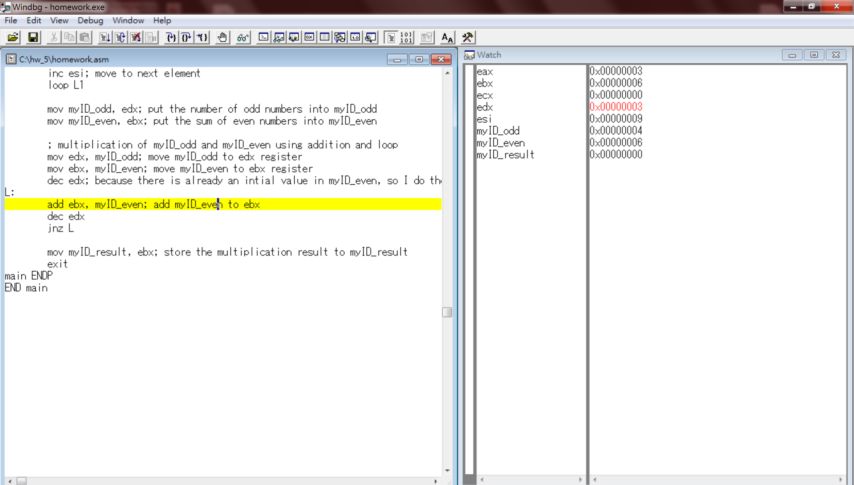
16. In the loop L, I’ll add myID_even to ebx every time, and then decrement edx to control the number of loops I will go through. When edx is decremented to 0, it will jump out of the loop since I used “jnz L” in the succeeding line to say that if only edx is not zero then loop L will be executed. After the first round, the value of ebx will become 12 which is c in hexadecimal and edx decrements to 2.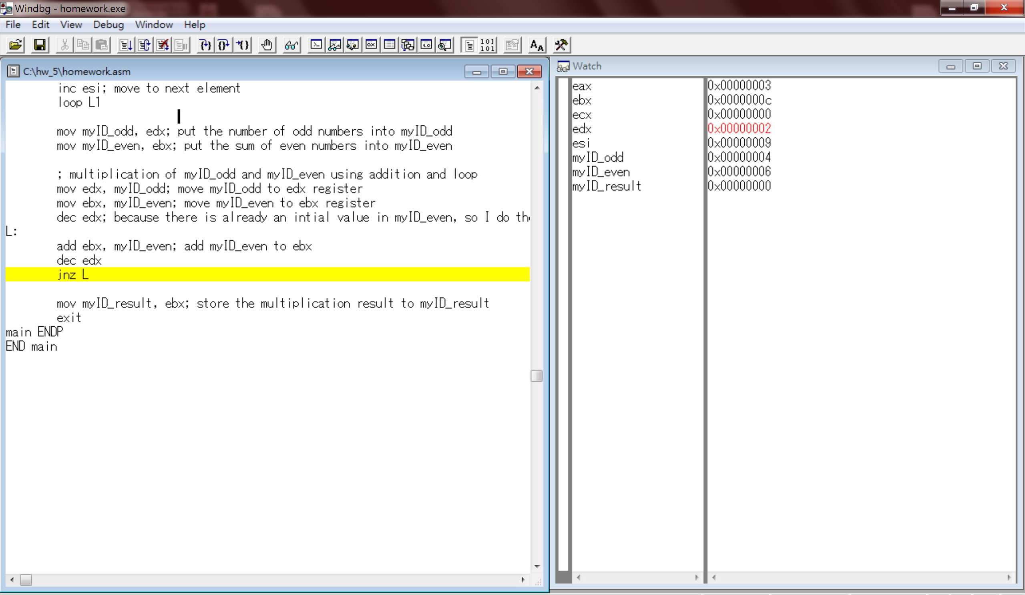
17. After the second round, the value of ebx will be 18 which is 12 in hexadecimal and edx became 1. 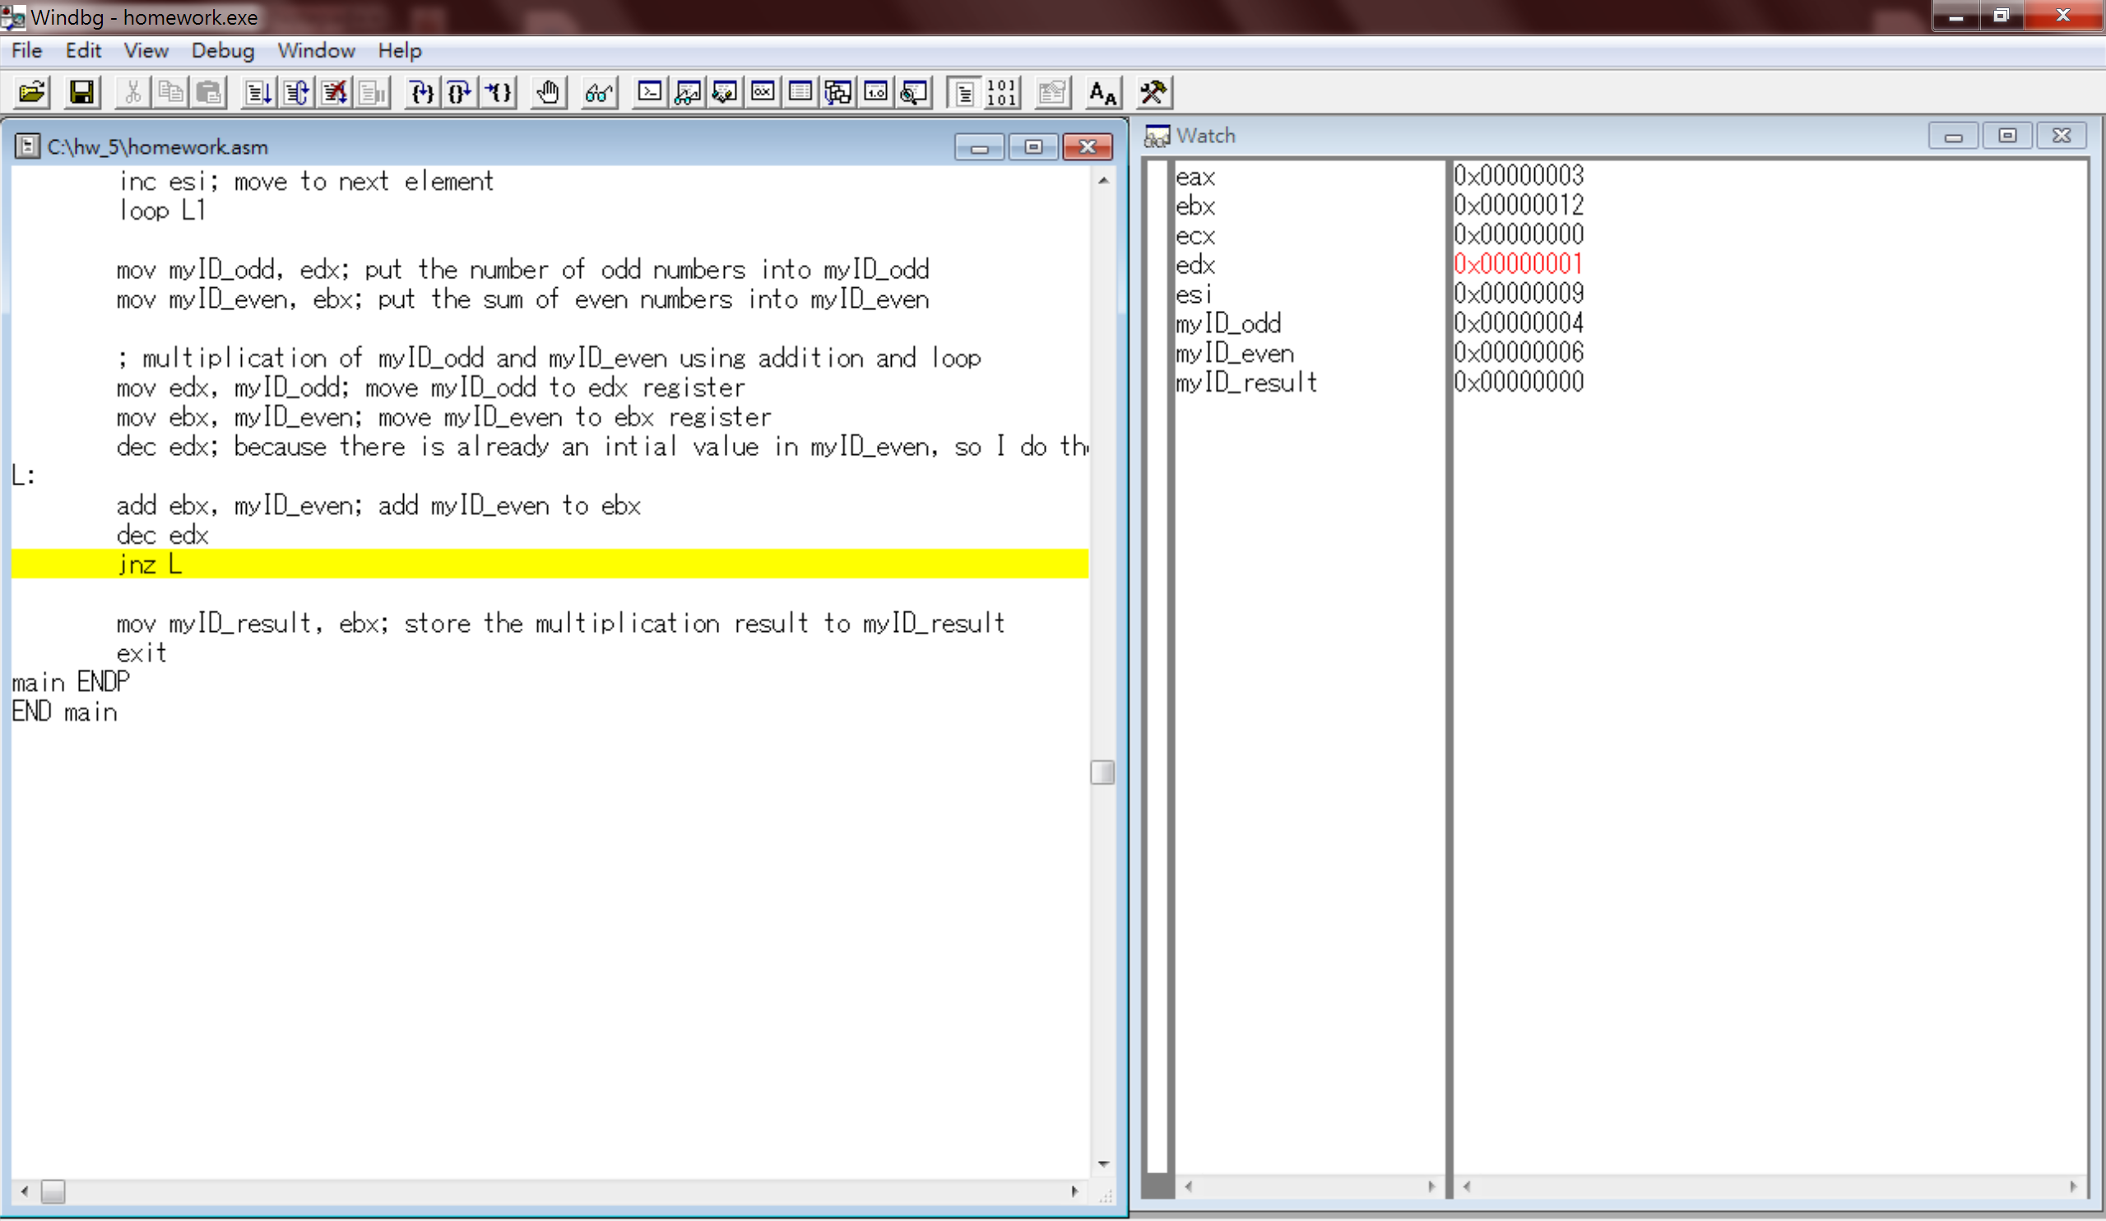
18. The last round, the value of ebx will finally become 24 which is 18 in hex and edx will become 0 so that it won’t go jump to loop L anymore.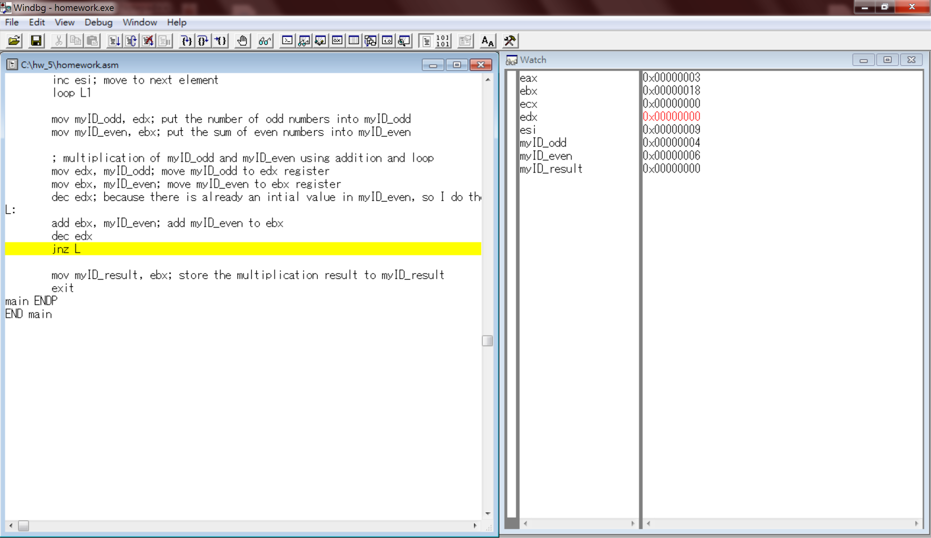
19. Now since we had the value of the multiplication of myID_odd and myID_even in ebx, we then move it to the variable myID_result. Therefore, we can now see that the value of myID_result becomes 18h.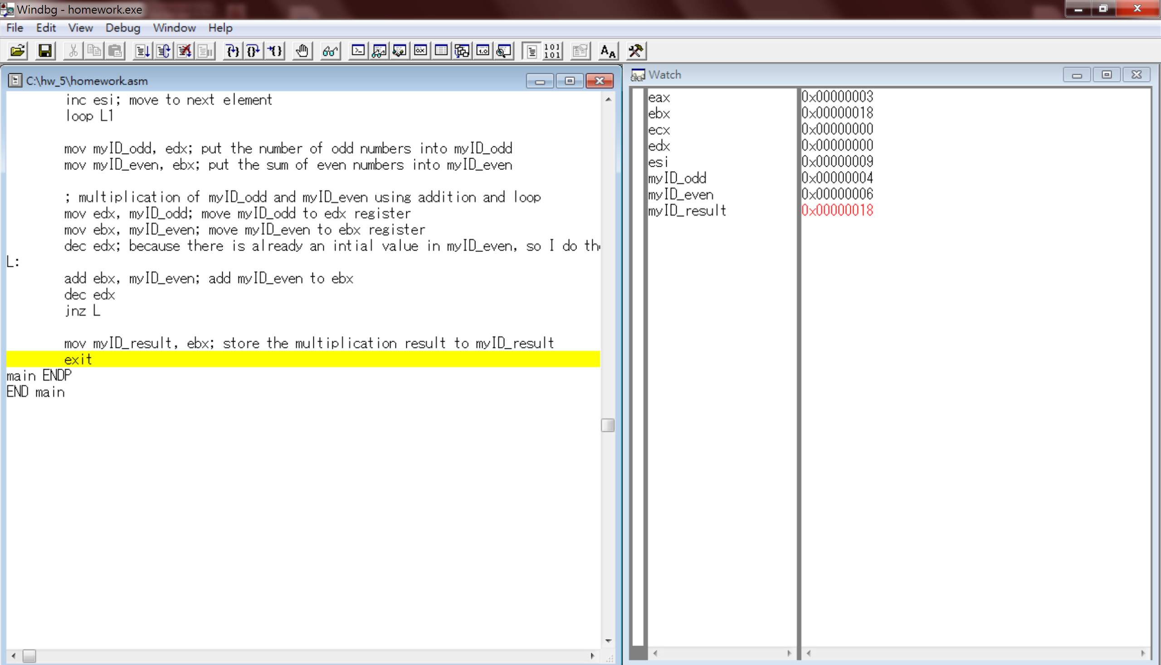
20. Last let’s take a look at the four variables myID, myID_odd, myID_even, myID_result in memory.

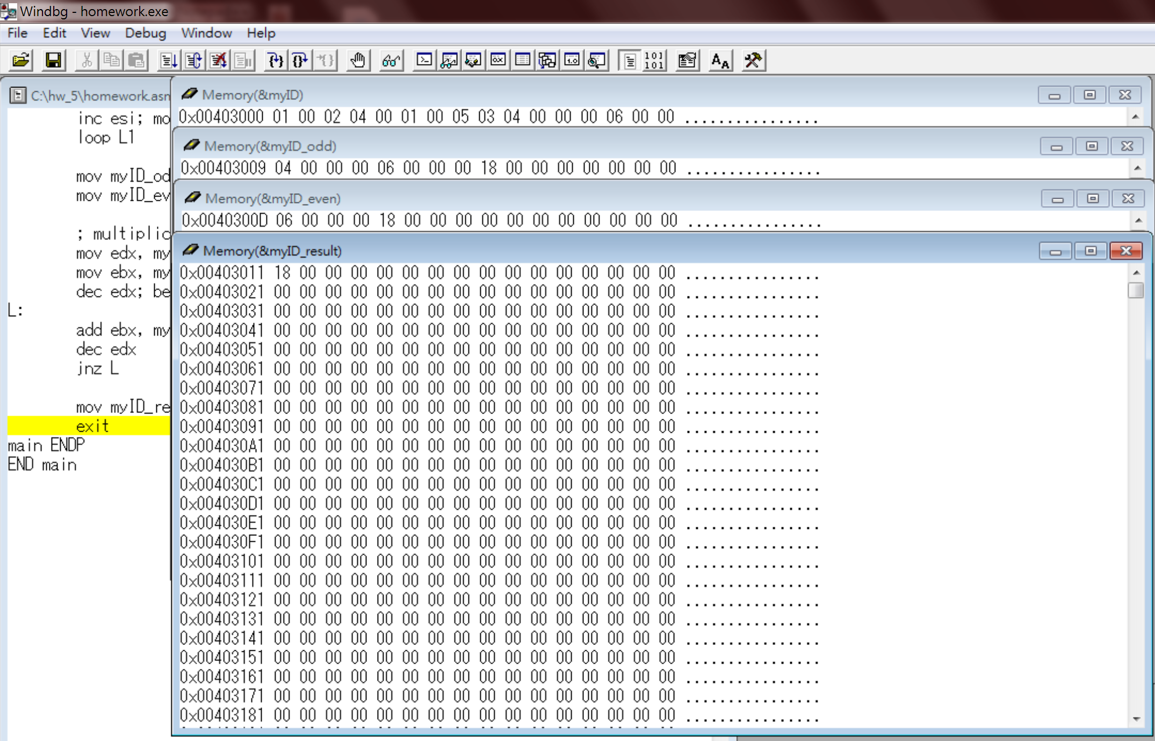

Reviews:

I really like the lab sessions because whenever I felt having trouble understanding the concepts during class, I will figure it out during programming. I was pretty lost while doing the guiding note of today’s; however, it’s is crystal clear after coding it by myself. I’m glad today I finished the code on my own without the help from the TA, but still thanks to the TAs with the clarification of some concepts. After this homework, I’m much more familiar with loops and some commands like jnz and test. There are still some commands mentioned during class that I haven’t tested on the code, I will practice on my own to understand it more.